**Relations in data base**

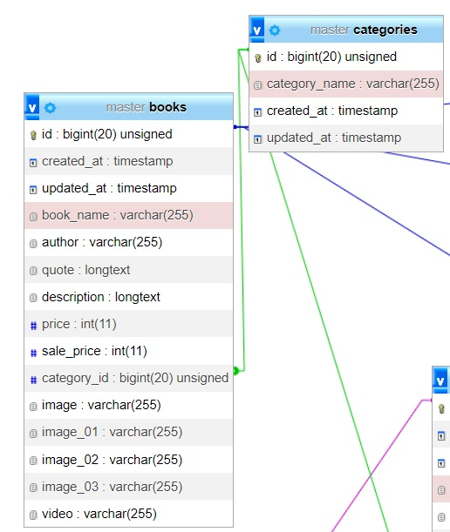

The relation in here is one to many relation one category has many books .

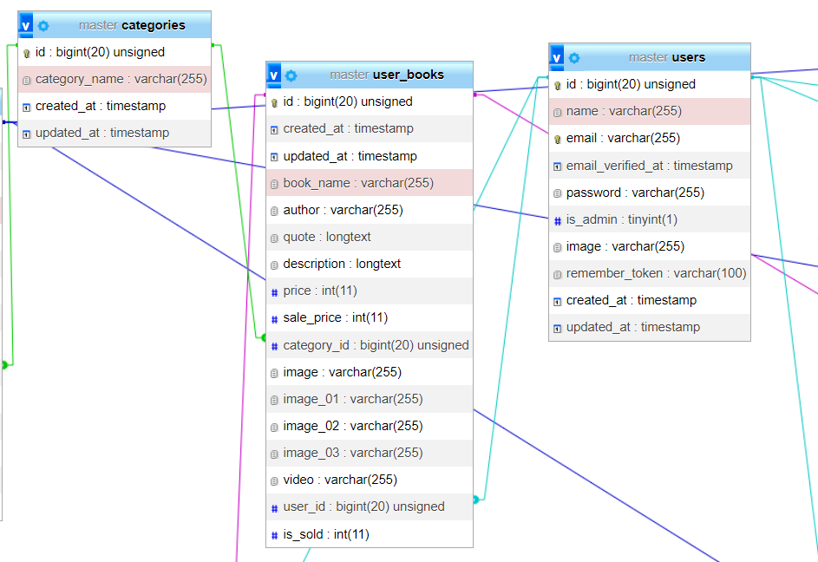

The relation in here between category and user book is one to many relation one category has many user books . The relation in here between user and user book is one to many relation one user has many user books .

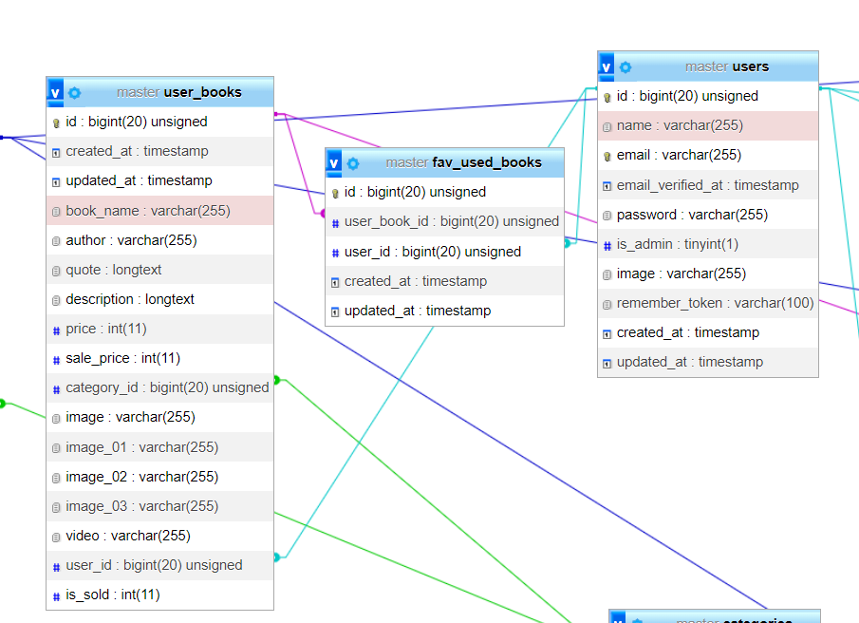

Fav used books here have one to many relation each user has many favorites and each user book has many favorites because the relation between user books and users is many to many.

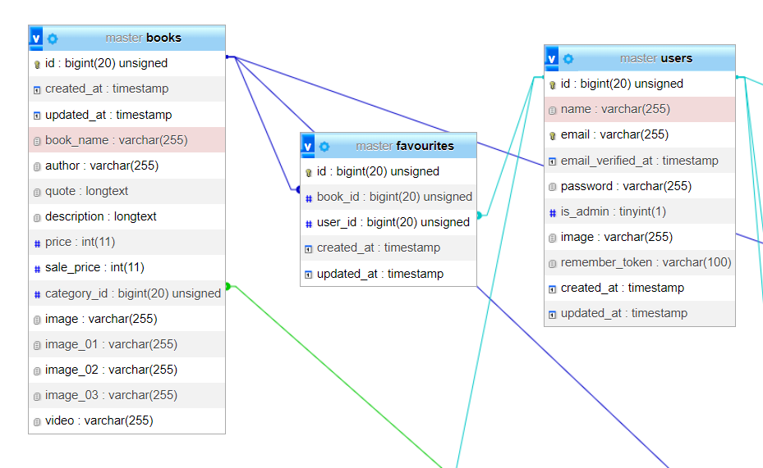

Fav books here have one to many relation each user has many favorites and each book has many favorites because the relation between books and users is many to many.

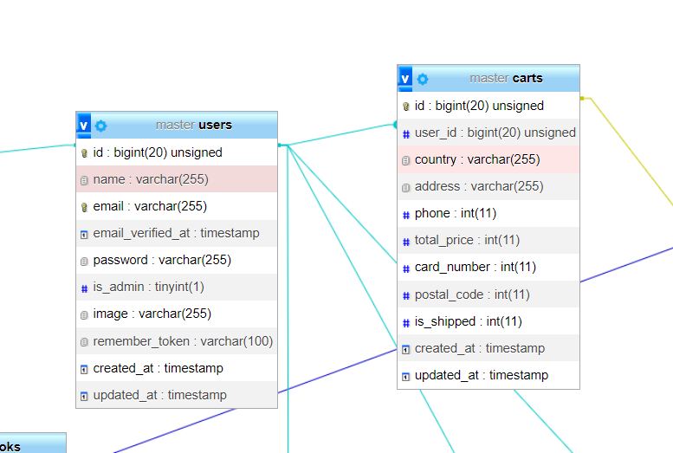

The relation between users and carts in here is one to many relation one user has many orders .

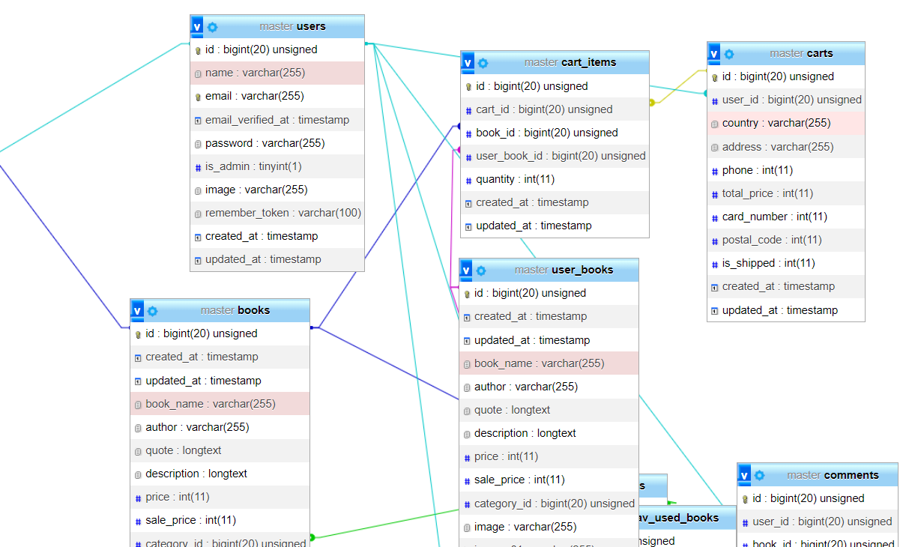

One to many between books and cart items is one to many each book can be in many orders and One to many between user books and cart items is one to many each user book can be in many orders AND One to many between cart and cart items is one to many each order can be in many cart items.

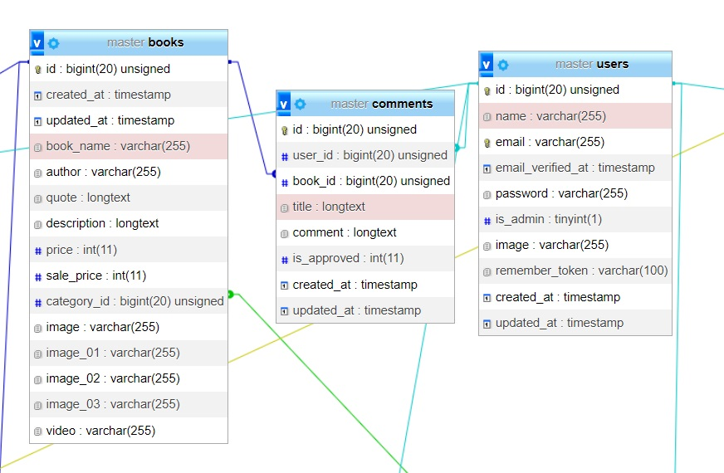

One to many between books and comments is one to many each book can be in many comments AND One to many between users and comments is one to many each user can have many comments.